# Structural Equation and Latent Variable Modelling

Confirmatory Factor Analysis example: Mental Health

## SF36 factor structure

The SF36 (Ware, 2000; Ware & Sherbourne, 1992) is a 36-item self-completion questionnaire that is designed to “screen” respondents to see if they may have health complaints that could benefit from clinical intervention. The 36 items ask respondents about topics such as pain, physical health, social functioning, mood, and mental health (see Figure 1, below).

Figure 1 below shows the assumed latent “factor” structure the authors assumed was underlying the observed responses. For example, the 10 items 3a. to 3j. ask about physical health and ability (examples: “Does your health now limit you in these activities: Lifting or carrying groceries?”, “Does your health now limit you in these activities: Walking a mile”?). The responses to these 10 observed items are assumed to reflect the effect of a single underlying dimension of variation, labelled “Physical Functioning (PF)”

The five observed items 9b to 9h (for example, “How much of the time during the past four weeks have you been feeling: nervous?”, “How much of the time during the past four weeks have you been feeling: happy?”) are assumed to reflect a core “mental health” (MH) factor[1]. Responses to these items are given on a six-point scale, with responses ranging from “None of the time” (coded as 1) to “All of the time” (coded as 6).

## References

Ware, J.E. (2000). SF-36 Health Survey Update. Spine. 25(24):3130-3139.

Ware, J.E. & Sherbourne, C.D. (1992). “The MOS 36-Item Short-Form Health Survey (SF-36): I. Conceptual Framework and Item Selection,”. Medical Care, 30:473-483.

## Further information

The full SF-36 questionnaire can be found here:   
<https://www.brandeis.edu/roybal/docs/SF-36_website_PDF.pdf> (Retrieved 21/02/2024).

Figure 1: SF36 factor structure from Ware (2000)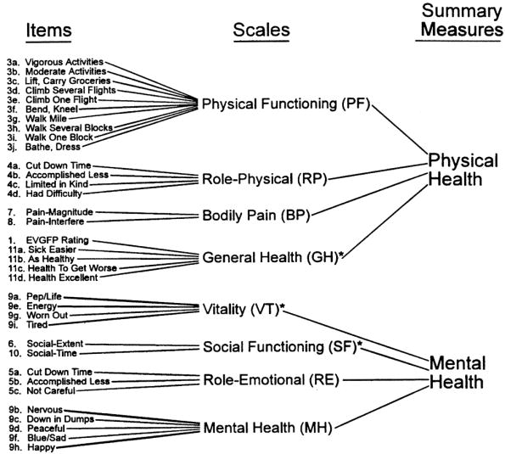

1. Note that there is also a broader mental health construct made up of four of the eight “core” factors, e.g. MH, RE, SF, VT. We won’t be considering that broader construct here, just the five-item MH scale.